**HORNINGSHAM PARISH COUNCIL**

**Action Plan**

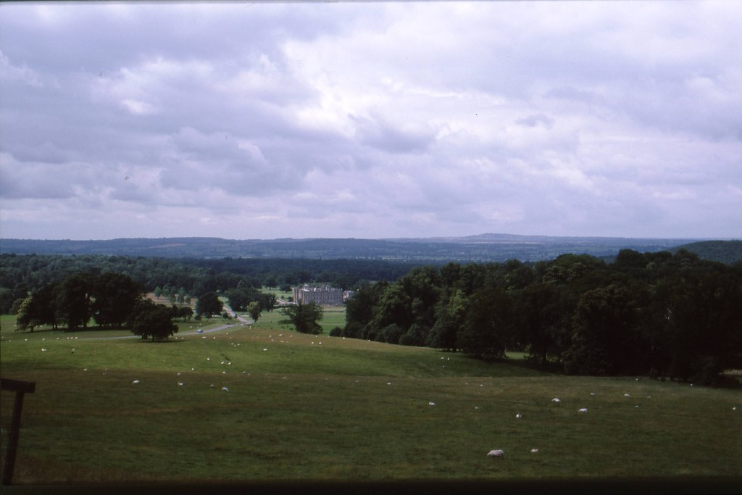

**CONTENTS**

Introduction 2

Context 2

The planning cycle 3

What is a Parish Council? 4

What can we do? 4

Powers and Duties 4

Accountability 4

What do we do? 5

What we achieved in the last year 5

What do we want to do next? 6

Issues and Actions 7

Review and performance 8

Comments 8

**Introduction**

Welcome to the Horningsham Parish Council. This is our Plan – it sets out what we are going to do over a rolling year period of two years. The Plan takes into account the issues facing us and our ability to respond with the resources available. It makes clear there will be choices, and how the Council will decide which to prioritise.

The Plan has been prepared and approved by your parish councillors. It is essentially a planning tool to assist us with the practical decisions we have to take when we meet 6 weekly, supported by a review process that helps us, and you, look back on our performance. By publishing our Action Plan, we can help those that live, work, or visit the Parish see what we are doing on their behalf.

**Context**

This Action Plan, prepared at a time of austerity across society when all organisations that provide services to the community, be they public, private, or voluntary are facing cost pressures and resource restrictions. The emphasis is on value for money, efficiencies, collaboration and accepting that some things just will not get done. Through a planning process though, we can have a shared vision and direction, protect what is important and consider new ways of getting things done.

Although not new, encouraging others to help themselves and not to rely on things being done for them is as important as ever. The aspiration for Wiltshire has been set out elsewhere as ‘building stronger and more resilient communities. That means communities that can help themselves, that have the networks and resources to find local solutions to local problems and have the means to ensure that wherever possible those that do need services can access them at a time and in a way that is most suitable.

Horningsham Parish Council, as the first tier of local government, is uniquely situated to provide the forum for understanding and supporting the needs of this community. It provides advocacy on behalf of its residents, uses linkages to other organisations to bring in services, or directly procures them itself. Liaison with Wiltshire Council happens at all levels, and there are linkages to health and social care as well. Day-to-day, the Council will seek solutions for the community, looking for skills and volunteers to make improvements to our surroundings or bringing particular neighbourhood issues to local attention to promote a better quality of life for all.

Above all your Parish Council is here to help, support and encourage. This Plan tells you how.

**The Planning Cycle**

Planning (and performance) is a continuous process of gathering and assessing information, formulating actions, *doing them*, and then reviewing performance and gathering again.

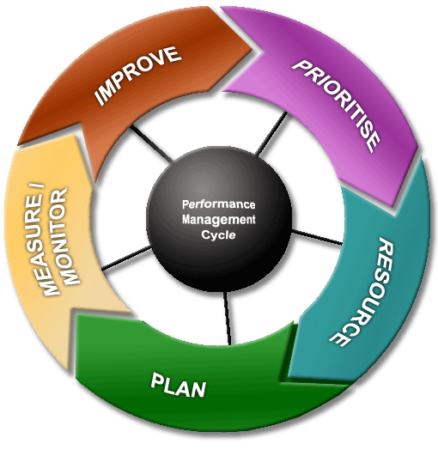

Of course, at key stages one has to pause and reflect, and consider how the plan is evolving – and not just once per year, as the plan is relevant to every significant decision made.

Once specific actions are agreed to deliver this Plan, they are entered on the Actions Register, which is monitored at every meeting of the Council.

**Linkages**

This Plan is linked very closely to the allocation of resources – mostly financial, but people’s time and energy too. Our finance is almost entirely derived from the Council Tax system, which follows the financial year April to March. Our precept, or ‘demand,’ placed upon the Council Tax system has to be declared every January, in order that Wiltshire Council can calculate the overall tax collection sums for each eligible household and produce the billing required.

**Key dates**

Therefore, this Plan will be drafted from November in each year, allowing it to evolve as the budget is also prepared, for final precept calculations in January. The Plan cycle will run from April to March, to match the funding available, and will be formally reviewed in May and November to assess achievements in the previous cycle, and progress in the current one.

July November January March May

look back, look forward improve, prioritise set precept completion review, resource.

**What is a parish council?**

MEASURE / MONITOR

There are two sorts of parishes whose boundaries do not always coincide:

* the Ecclesiastical Parishes centred on an Anglican church with a parochial church council and,
* the Civil Parishes, which are part of local administration, having a parish (or town) council.

A civil parish is an independent local democratic unit for villages, smaller towns, and suburbs of urban areas. Each parish has a Parish (or Town) Meeting consisting of all its local government electors and most (where the electorate exceeds 200) have a Parish or Town Council. Approximately 350 electors live in the parish of Horningsham.

The parish council is a small local authority. Its councillors are elected for four years at a time in the same way as for other councils. Bye-elections may be held to fill vacancies occurring between elections, or members may be co-opted onto the Council if no election is called. The council is the corporation of its parish in the Wiltshire area, it covers the village of Horningsham. In May, each year the councillors choose a chairperson from amongst their number. In the Horningsham Parish, there are 11 councillors who make up the Parish Council, which employs a part-time Clerk to manage administration.

**What can we do?**

**Powers and Duties**

Parish councils have a number of formal powers, set out in a wide range of legislation. A duty is something that a council must do, a power is something that it may do, if it so decides. A parish council cannot do anything that is not permitted in law.

Parish Councils in Wiltshire have lately become more significant, as District Councils have been removed and because the unitary authority could then seem more remote. The parish councillors know the villages and can now (and increasingly often do) represent their views directly to other authorities like the Unitary Council at its Area Boards, Health Authorities, Police and Fire Authorities. They are entitled to be consulted on planning applications, which include work to listed buildings and on proposals in conservation areas and are often consulted on such things as schools and roads. They put the parish’s case at public inquiries. Moves from Government toward greater 'localism' are set to increase the role of Parish Councils even further, especially in the field of development control and planning.

**Accountability**

You elect its members every four years - the next time will be May 2025 - and you are entitled to attend the annual parish meeting (in May) and to say what you think. You can also go to every meeting of the Parish Council and meet the Council members, listen to their business, and participate in the time especially set aside for that purpose at the start. The accounts are strictly audited every year and published.

You can find out more about what we do, how we do it, and our meetings on the parish website at [www.horningshamparishcoucnil.gov.uk](http://www.horningshamparishcoucnil.gov.uk)

**What do we do?**

The Parish Council provides a number of direct services to the community, and acts as custodian to a number of assets held in the 'public name'.

The assets held in the public name are two Park Benches, the Chapel signpost, one Notice Board, Street Furniture/Grit Bins, Childrens Play Area, Office Equipment comprising a Laptop, Monitor, A3 Printer/Cables, and a Computer Chair. The Council is responsible for maintenance, repairs and insurance for these items and facilities.

Although Wiltshire Council is the Planning Authority, the Parish Council is consulted on each planning application made in the parish. Councillors consider planning applications at their meetings and inform Wiltshire Council of their comments/views.

At each meeting of the Council, reports from a variety of village organisations are received, and Councillors seek to provide support where necessary or requested in order that local groups can continue to thrive. Reports include observations from the Village Hall Committee (consisting of both councillors and volunteer members of the public) Each meeting considers issues for our communities such as planning (for example, housing or tree felling) speeding, inappropriate use of rights of way, crime and community safety, facilities for young people, or items of maintenance in the 'public realm' that need reporting to appropriate authorities. The Council can act as advocate for residents, a conduit for communicating information, and will liaise with appropriate departments of other public authorities to ensure that views, comments, and necessary actions are dealt with.

**What we achieved in the last year**

We have achieved a wide range of improvements, both to the way we work, and to the community we serve:

**Adopted** all rules and procedures as per Government legislation and the National Association of Local Councils guidelines.

**Established** a paperless office environment, regular Community Consultation using Microsoft forms and the use of the Horningsham News Community Facebook pages.

**Debated** a range of traffic, transport, and road safety issues leading to representation at the Warminster Area Board, Community Traffic Action Group and Neighbourhood Tasking Group Meetings

**Considered** 10planning applications, most of which were supported by this Council.

**What do we want to do next?**

The Parish Council has worked through the parish plan working group’s findings and added a few issues to the Action Plan.

The table below sets out the Action Plan adopted by the Council.

| **Ser** | **Issue** | **Action** | **Lead Partners** | **Resource Implications** | **Timescale** |
| --- | --- | --- | --- | --- | --- |
| **Long-term Overview** | | | | | |
| 1 | Maintain impetus of Action Plan | Formal and regular overview by Parish Council | HPC | Nil | At HPC discretion |
| 2 | Maintain relevance of Parish Plan | Annual review by HPC | MBPC | Nil | At HPC discretion |
| **Facilities and Services** | | | | | |
| 3 | Providing facilities for children, young people, and families | Review the recreational area facilities and capture ideas for teenagers | HPC | Seek Grants use Youth Club Funding | Two years |
| **Crime and Community Safety** | | | | | |
| 4 | Maintaining current satisfactory situation. | Maintain current Neighbourhood Watch organisation.  Encourage reporting of fly tipping to Wiltshire Council.  Maintain periodic ‘litter pick.’ | HPC Volunteer  All residents | Small. Some assistance available from Wiltshire Council for ‘litter pick.’ | Regular and frequent monitoring |
| **Culture, Leisure, and Recreation** | | | | | |
| 5 | Need for innovative ideas, particularly for children and young people | Capture ideas for future consideration | HPC, consultation with Village Hall Committee and Community | Small consultation expenses printing | Continuing |
| **Local Economy and Tourism** | | | | | |
| 6 | Assisting the local economy, including encouraging tourism | Advertise on the countryside walks, etc in the parish.  Pass on Wiltshire Council information bulletins to the Community | HPC | Will evolve out of planning actions | Continuing |
| 7 | Assisting economic growth | Advertising in the Horningsham News to businesses. Working with the Village Hall Committee.  Using the Facebook pages to sign post business grants and opportunities. | HPC, Horningsham News Editor, Village Hall Committee  Wiltshire Council | None | Continuing |
| **Education and Communications** | | | | | |
| 8 | Improve communication of Parish Council activities | Horningsham News  Facebook Page  Noticeboards  Liaise with the School on projects or events. | HPC | None | Continuing |
| **Environment and Countryside** | | | | | |
| 9 | Maintain support for conservation and restoration in village and countryside | Work with Rights of Way Volunteers | HPC  Farmers  Nigel Linge | £2,500 | Continuing |
| 10 | Improve knowledge and understanding of Rights of Way, their use and accessibility | Advertise Rights of Way Standard  Request feedback on condition of rights of ways walked by parishioners, allocate a walk to a volunteer to report back on its condition. | HPC  Farmers  House owners  Tenants | Facebook pages  Horningsham News | Continuing |
| **Health and Social Care** | | | | | |
| 11 | Improve support to older people | Support the Luncheon Club to examine mutual support by/for older people, provision of further outside support. | HPC  Luncheon Club  Wilshire Community Services. |  | Continuing |
| **Housing, Development, and the Built Environment** | | | | | |
| 12 | Taking forward local preferences when considering local planning applications. | Neighbourhood Plan  Parish Plan Consultation | HPC | Nil | Discounted as no areas identified for development to take place in the parish.  Longleat is a private estate Tourism its main  target for future development. It is also a conservation area with many listed buildings and park areas.  The Parish Plan used to seek views. |
| 13 | Wiltshire Council’s respect for local views in determining housing strategy allocations and individual planning applications. | Housing Survey Kept updated regularly | HPC | Nil | Continuing |
| **Transport and Traffic** | | | | | |
| 14 | Tourism Traffic | Monitor speeding and traffic volume during events.  Action metro Counts to secure the use of Speed Indicator Devices in areas of issue.  Work with Wiltshire Council to action a Speed Assessment study throughout the Village. | HPC | Possible match funding required | Continuing |
| **Crime and Community Safety** | | | | | |
| 15 | Neighbourhood Watch | Volunteer/Councillor to action this project | HBPC  Parish News  PCSO | Volunteer to receive support and be able to use the Horningsham news & Facebook as a reporting medium.  Liaise with Local PCSO for crime reports in the Community | Continuing |