Annual Report (May 2024)

Wiltshire Council’s Annual Report for Town and Parish Councils can be found at Resources for Town and Parish Councils - Democratic Services - Wiltshire Council
Overall, the council's budget for 2024/25 stands at around £490m. More than half of that is spent on adult and children's social care services.
Secure Finances – Investing in Key Services: Despite the ongoing budget pressures arising from increasing demand for services and inflationary costs, the Council has been able to effectively manage these challenges to ensure a firm financial footing. Key to this sustainable approach to delivering for Wiltshire, is to invest in services, especially those which tackle issues in a proactive way. The Council receives nearly 83% of its funding from local taxes, Business Rates and Council Tax, so we take delivering on our promises to local people very seriously.
The most significant spending in 2024/25 will be on:
- Adult services - £179.4m
- Families and children - £70.8m
- Education and skills - £38.9m
- Environment - £49.6m
- Highways and transport - £43m
How the money come is spent
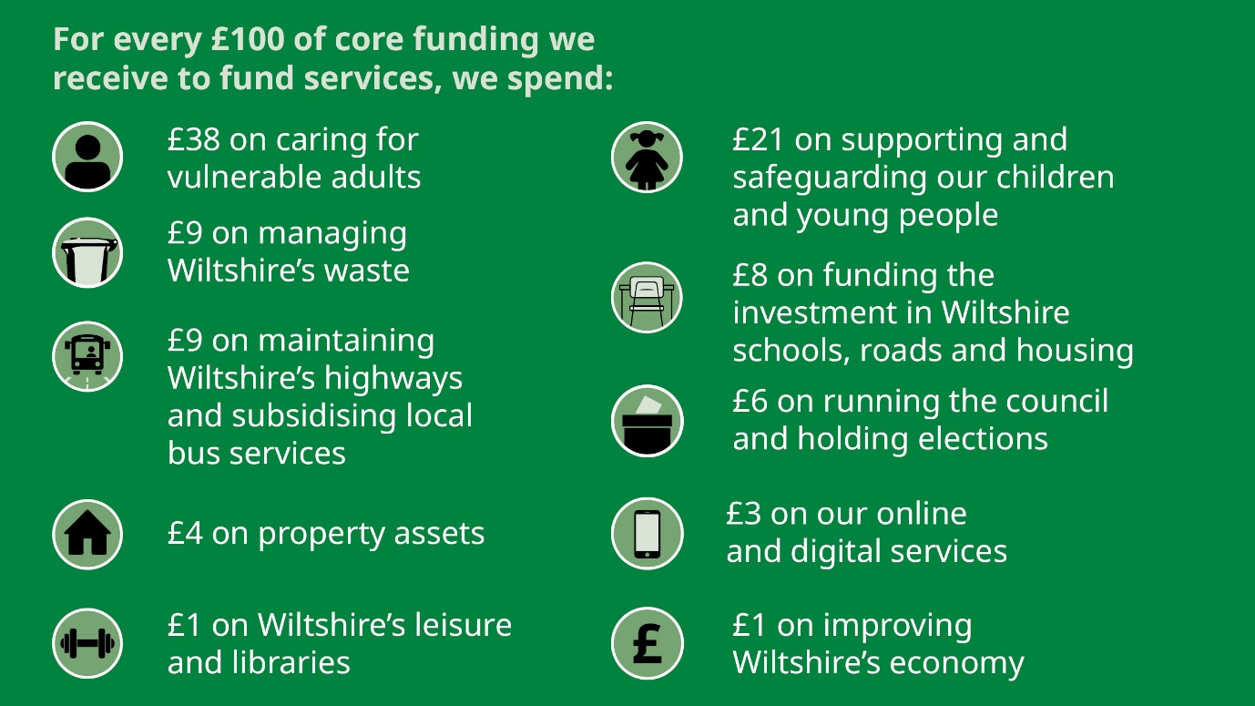

Here are some highlights:-
Children’s Services – Outstanding Ofsted: We want to give Wiltshire’s children the best start in life as it is fundamental in improving their long-term life chances and gives them the best opportunity to live full and healthy lives. We have worked relentlessly to improve our services and now deliver consistently Outstanding services that ensure the needs of families and children are met at the right time by the right people. This is reflected in the Ofsted inspection report from November 2023 that rated us Outstanding across the board.
Additional Funding for Highways & Flood Prevention: Heat, flooding and severe winter weather has caused significant damage to some of Wiltshire’s roads in 2023. Whilst the overall condition of Wiltshire’s classified road network is better than the national average this continues to be a priority. We are investing an additional £10m in Highways maintenance, which together with increased Department for Transport (DfT) funding, will enable an extensive programme of road surfacing and treatment in 2024/25. We are also investing an additional £1m to support preventative drainage programmes and have confirmed additional £1.5m funding from 25/26 onwards to help with gully cleaning and potholes.
£179m for Adult Services, which includes over £9m of efficiency savings: Adult Social Care accounts for the highest percentage spend of Wiltshire Council’s budget and continues to see significant demographic and cost pressures. The Transforming Adult Social Care programme ensures that the Council is proactive in ensuring services meet need. Continued investment is being made in preventative, enablement and reablement services that support people to stay in their own homes and take full part in their communities. The Shared Lives Scheme, which offers a fostering style model of care and support continues to grow, and the use of Technology Enabled Care (TEC) is a key priority. Moving from children to adult services is one of the most critical times for anyone’s life, this is even more important for young adults who have Special Education Needs and Disabilities.
Locally, I have continued to support Parish Councils and residents with specific local matters, and I have attempted to attend the Parish Council meetings across the area.
As chairman of the Local Highway Footpath Improvement Group, I am very pleased to support parish highway improvement schemes brought before the group. I will continue to press for road safety improvements across the area, especially near schools and seek a resolution to speeding vehicles and HGV’s seeking short-cuts and travelling through the villages.
I have been delighted to gain various grants for village organisations and will continue to ensure that the villages never become forgotten in the wider context.
Looking forward, I will continue to listen to local views on planning applications and support efforts to ensure that the applications only delivery sympathetic outcomes where planning policy permits.
It has been a pleasure to support Parish Councils, community groups and residents with a whole host of local issues over the last year including flooding, road safety, footpaths, and planning matters. If there is a local issue that you are concerned about, please do get in touch and I will do my very best to help.
I hope you feel that your village has benefited from our joint efforts with your local projects and concerns.
Finally, I would like to say a huge thank you to all the Parish Councils across Warminster Rural West – they and the many other local organisations help ensure our villages are such fabulous communities and brilliant places to live.
Bill Parks
Wiltshire Councillor for Warminster North and Rural.
Tel: 07712 490075
Email: bill.parks@wiltshire.gov.uk

