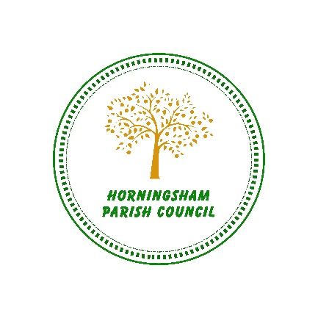

Horningsham Parish Council

Application for Grant for Voluntary Organisations

Please note that this application will not be considered unless it is accompanied by a copy of the latest set of annual accounts showing the organisations income, expenditure and level of balances. If the organisation does not prepare annual accounts, copies of the bank statements covering the previous six months must be enclosed.

All applications must be returned to the Clerk for the application to be discussed by Council at the Parish Council meeting. Forms can be posted to the Clerk at 78 Boreham Road, Warminster BA12 9JN or emailed to: clerk@horningshamparishcouncil.gov.uk

Any application awarded a grant would be notified in writing or by email (if requested) and sent via a bank credit to the organisation named below.

1. | Name of Organisation applying for the grant - name for the payment.
2. | Name, Address and Status of Contact.
3. | Telephone Number of Contact.
4. | Is the Organisation a Registered Charity? Please provide registration number.
5. | Amount of grant requested.
5. | For what purpose or project is the grant requested?
6. | What will be the total cost of the above project?
7. | If the total cost of the project is more than the grant, how will the remainder be financed?
8. | Have you applied for a grant for the same project to another organisation?  If so, which organisation and how much?
9. | Who will benefit from the project?
10. | Approximately how many of those who will benefit are residents?

You may use a separate sheet of paper to submit additional information which support the application.

All grant monies must be spent on the purpose for which it was granted, if not it is to be returned to the Parish Council. Proof that the funds were used for the purpose they were granted will be required, e.g. photographs or a letter from residents who have benefitted.

Signed………………………………………Date…………………………

