Horningsham Parish Council

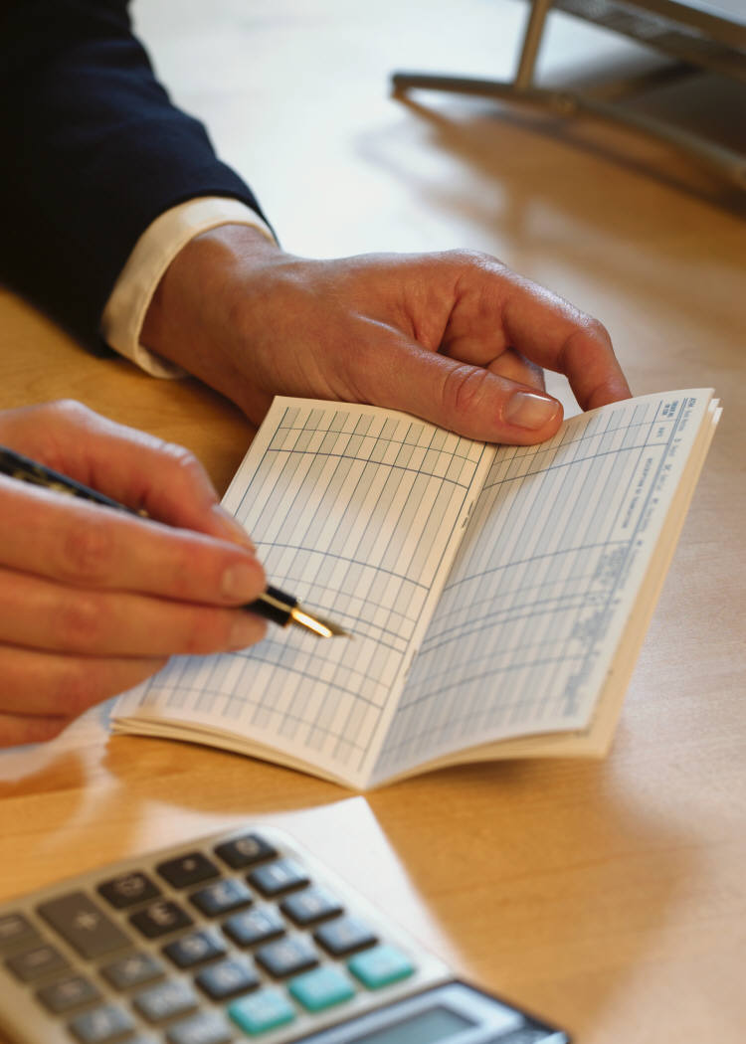

Procedural document to cover the key financial procedures performed by the Parish Clerk

